[Fast French Bread or Rolls](http://markbittman.com/fast-french-bread-or-rolls)

04|22|11

[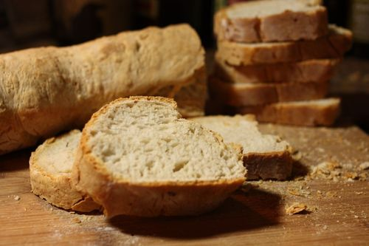](http://markbittman.com/fast-french-bread-or-rolls)

Makes: 3 or 4 baguettes, 1 boule, or 12 to 16 rolls

Time: About 2 hours, largely unattended

This bread can be made by hand or with an electric mixer, but the food processor is the tool of choice and will save you tons of time. Recipe from [How to Cook Everything](http://www.amazon.com/gp/product/0764578650/ref=pd_lpo_k2_dp_sr_1?pf_rd_p=486539851&pf_rd_s=lpo-top-stripe-1&pf_rd_t=201&pf_rd_i=0028610105&pf_rd_m=ATVPDKIKX0DER&pf_rd_r=11NDKV4CHVPPF5PNT7MW).

3 1/2 cups all-purpose or bread flour, plus more as needed

2 teaspoons salt

1 1/2 teaspoons instant yeast

1. Put the flour in a food processor. Add the salt and yeast and turn the machine on; with the machine running, pour about a cup of water through the feed tube. Process until the dough forms a ball, adding a tablespoon more water at a time until it becomes smooth; if the dough begins sticking to the side of the bowl, you’ve added too much water. No harm done: add 1/4 cup or so of flour and keep going. You’re looking for a moist, slightly shaggy but well-defined ball. The whole process should take about 30 seconds, and it will once you get good at it. If the dough is too dry, add water 1 tablespoon at a time and process for 5 or 10 seconds after each addition. If it becomes too wet, add another tablespoon or two of flour and process briefly.

2. Dump the lump of dough into a large bowl or simply remove the blade from the processor bowl and leave the dough in there. Either way, cover with a plastic bag or plastic wrap and let sit for at least an hour at room temperature.

3. Use a small strainer or your fingers to dust a little flour onto a counter or tabletop. Shape the dough as you like, into small loaves, one big one, baguettes, or rolls, sprinkling with flour as necessary but keeping the flour to a minimum. Heat the oven (with a pizza stone and/or a pan filled with rocks if you have them) to 400°F while you let the breads or rolls rise, in a cloth if you like, covered with a towel.

4. When you are ready to bake, slash the top of each loaf once or twice with a razor blade or sharp knife. If the dough has risen on a cloth, slide or turn it onto floured baking sheets or gently move it onto a lightly floured peel, plank of wood, or flexible cutting board, then slide the bread directly onto a pizza stone. Or you can bake on lightly oiled baking sheets. Turn the heat down to 375°F.

5. Bake until the crust is golden brown and the internal temperature of the bread is at least 210°F (it can be lower if you plan to reheat the bread later) or the loaves sound hollow when tapped. Remove, spray with a bit of water if you would like a shinier crust, and cool on a wire rack.